Chang’an University 2024－2025 The 2nd semester （ A ）
Course | Hydraulic and Pneumatic Transmission |  |  | Date |  | / / |  | 18 questions
Name |  | School |  |  | Class |  | ID
I Fill in the blanks. (20 points, 1 point for each blank)
- The working pressures in the hydraulic system depend on the outside load . The speed of the actuating element depends on the flowrate .
- The viscosity of the oil is highly sensitive to temperature. When the temperature of the oil rises, its viscosity will decrease.
- The hydraulic system is mainly composed of five parts. Among them, the component that converts pressure energy into mechanical energy is actuator element. The component that control and regulate the pressure, flow rate and flow direction of the oil is control element.
- According to Reynolds test, the main states of fluid flow are laminar flow and turbulent flow in a pipe.
- Hydraulic pumps can be classified by the forms of main moving components and their moving manners: gear pumps, vane pumps, piston pumps and screw pumps, etc.
- The common pressure operated valves include relief valves, pressure-reducing valves, sequence valves and pressure relay.
- The speed-regulating valve is composed of two valves connected in series. They are throttle valve and fixed differential pressure-reducing valve.
- According to the different installation positions of the throttle valve in the circuit, the throttle speed-regulating circuit is divided into inlet throttle speed-regulating circuit, outlet throttle speed-regulating circuit and bypass throttle speed-regulating circuit.
- Sequence action circuits allow several actuator motions to obey the setting scheduled actions in turn. There are two kinds of control methods: pressure control and distance control.
II Short answer question items. (20 points, 5 points for each)
- What are the advantages of hydraulic transmission?
1) The hydraulic equipment system has smaller volume, light, high power consistency and compact configuration at a given power.
2) has a good working stability.
3) can reach a wide range of speed regulation
4) The hydraulic transmission can easily realize automation.
5) can protect from over-load easily.
6) the hydraulic system is easier in design, fabrication and application.
7) The hydraulic system is easier than machine equipment in doing line motion.
(答对4个以上5分)

第 1 页(共 4 页)
- What is the displacement of hydraulic motor? Please explain the volumetric efficiency and mechanical efficiency of hydraulic motor?
The displacement of hydraulic motor is defined as the needed oil volume per revolution of the motor output shaft without oil leakage when the volumetric efficiency equals 1. (3 points)
The volumetric efficiency of hydraulic motor is the ratio of theoretical flow rate to the practical flow rate. (1 point)
The mechanical efficiency of hydraulic motor is the ratio of practical output torque to the theoretical torque. (1 point)

- As shown in the figure below, this is the characteristic curve of the pressure-limited variable pump. Please briefly explain the reasons for the changes in flow rate of AB section and BC section with the variation of pressure?
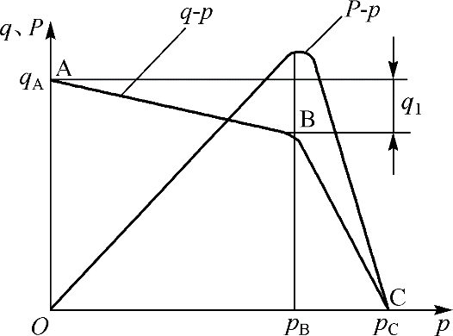
The flow rate of the pressure-limited variable pump decreases as the output pressure increases. Theoretically, when the working pressure is less than the pre-set limit pressure, the hydraulic force cannot overcome the pre-tightening force of the spring. At this time, the eccentricity of the stator remains at its maximum value and the pump's output flow rate remains unchanged. However, in reality, as shown in segment AB of the figure, since the supply pressure increases, the leakage flow of the pump also increases, so the actual flow rate of the pump slightly decreases. (3 points)
As shown in segment BC, when the pump's output pressure reaches P_{B}, it reaches the pre-set limit pressure. The eccentricity of the vane pump decreases, and the pump's output flow rate decreases rapidly as the output pressure increases. (2 points)
- Please write out the differences between pilot operated relief valves and pilot operated pressure reducing valves.
1) the pressure reducing valve holds the outlet pressure constant, whereas the relief valve holds the desired reduced pressure at the inlet. (2 points)
2) the pressure reducing valve is normally open while the relief valve is normally closed. (2 points)
3) the pressure exists in both inlet and outlet ports of pressure reducing valves, so the leaking oil from the spring port of pilot valve must induced separately to the reservoir. But the outlet pressure oil of relief valve flows directly into the reservoir and the leaking oil from the spring port of pilot valve discharge out through the inner passages of valve body. (1 point)
III Calculations. (30 points)
1. There is a water storage device as shown in the figure. The water storage tank is large enough. When the valve is closed, the reading of the pressure gauge is 2.8 atmospheric pressure. While when the valve is fully opened and water flows out from the pipe, the reading of the pressure gauge is 0.6 atmospheric pressure. Please calculate the flow rate through the outlet when the pipe diameter d = 12 cm (ignoring flow losses, assuming 1 atmospheric pressure is 1×10⁵ Pa and the gravitational acceleration g is 10 m/s²) (10 points)
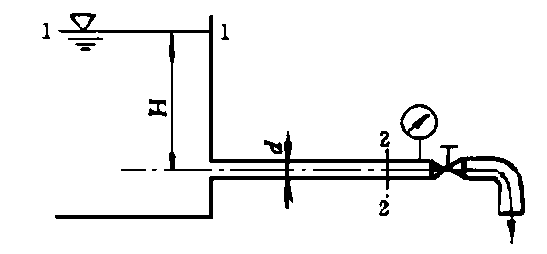
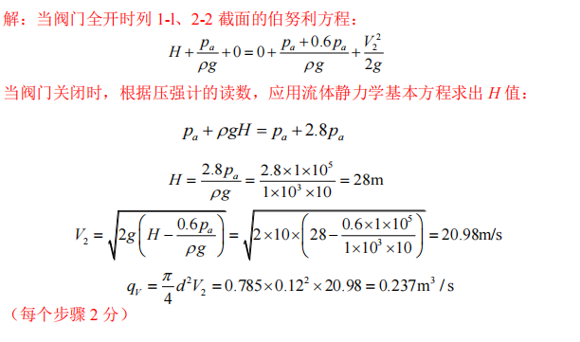
2. The inlet pressure of a hydraulic motor is 10MPa, the displacement is 200mL/r, the total efficiency is 0.75, and the mechanical efficiency is 0.9.
1) The theoretical torque that the motor can output.
2) If the speed of the motor is 500r/min, what is the flow rate of the infusion motor?
3) If the external load is 200 N∙m (n= 500r/min), what is the output power and input power of the motor? (10 points)
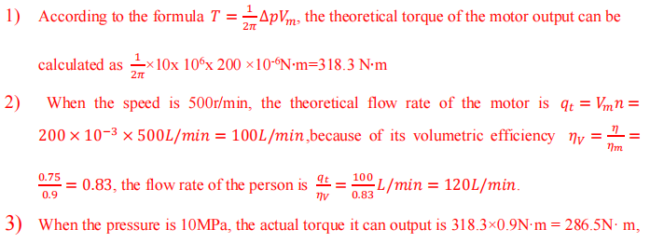

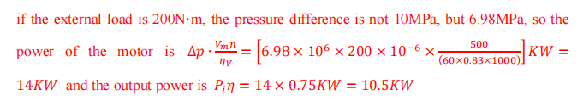
3. As shown in the figure, the setting pressure of the relief valve of the system is 5MPa, and the setting pressure of the pressure reducing valve is 2.5MPa. Try to analyze the following conditions, and explain the pressure reducing valve port in what state?
1) When the outlet pressure of the hydraulic pump is equal to the set pressure of the relief valve, how much is the pressure at point A and C after the clamping cylinder makes the workpiece clamp?
2) When the outlet pressure of the hydraulic pump is reduced to 1.5MPa due to the fast forward of the working cylinder (the workpiece is originally in the clamping state), how much is the pressure at point A and C?
3) When the clamping cylinder makes no-load movement before clamping the workpiece, what is the pressure of point A, B and C?
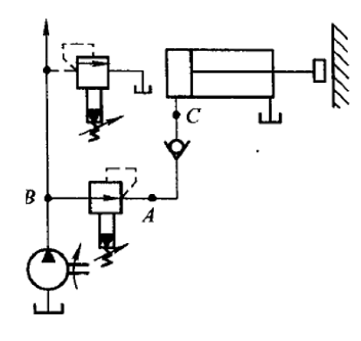
1) When the workpiece is clamped, the clamping cylinder pressure is the adjustment pressure of the pressure reducing valve, 𝑝𝐴=𝑝𝐶= 2.5MPa. The opening of the pressure reducing valve is very small, at this time there is still a part of the oil through the small opening of the alkali pressure valve heart (or triangular groove), the pilot valve is opened and discharged, and the valve port of the pressure reducing valve is always in the working state.
2) When the pressure of the pump suddenly drops to 1.5MPa, the inlet pressure of the pressure reducing valve is less than the adjustment pressure 𝑝𝐽, the valve port of the pressure reducing valve is fully opened and the pilot valve is in the closed state, the valve port has no decompression effect, 𝑝𝐴=𝑝𝐵= 1.5MPa. The point C pressure after the check valve, because the original clamping cylinder is at 2.5MPa, the check valve has a pressure holding effect in a short time, so pc = 2.5MPa, so as not to loosen the clamping workpiece.
3) When the clamping cylinder is in no-load rapid movement, 𝑝𝐶=0. If the pressure at point A does not consider the pressure loss caused by oil flowing through the check valve, 𝑝𝐴=0. Because the pressure reducing valve port is fully open, if the pressure loss is not considered, 𝑝𝐵=0. It can be seen that the working pressure of the pump will be affected when the clamping cylinder moves rapidly without load.

第 2 页(共 4 页)

IV Diagramming question. (15 points)
1. Please write the name of basic hydraulic circuits and hydraulic components (10 points).
(1) | (2)
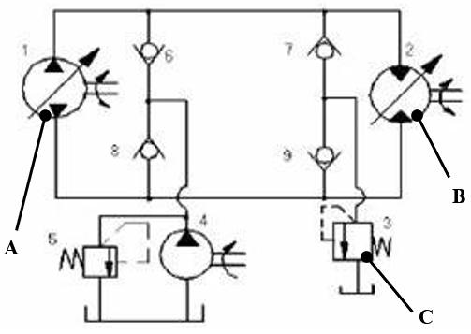 | 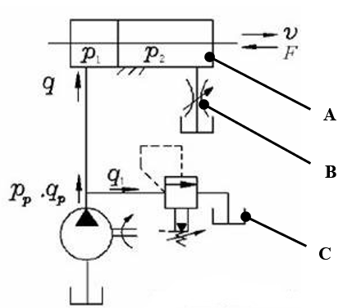

Hydraulic basic circuit | Volume speed regulating circuit |  | Hydraulic basic circuit | Outlet throttle speed regulating circuit
Component A | Bidirectional variable pump |  | Component A | Double-acting double-piston rod hydraulic cylinder
Component B | Bidirectional variable motor |  | Component B | Throttle valve
Component C | Direct-acting relief valve |  | Component C | Reservoir (oil tank)
2. Please draw the symbol diagram of the following components. (5 points).
(1) Three-position four-way manual directional control valve | (2) Hydraulic-operated check valve | (3) Speed-regulating valve
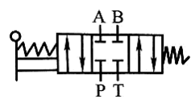 | 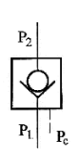 | 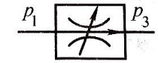
(4)Pilot-operated pressure-reducing valve | (5) Internal control external discharged sequence valve
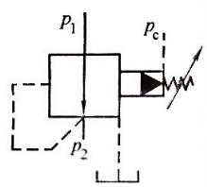 | 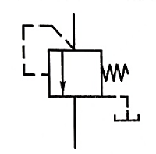

第 3 页(共 4 页)
V Analysis. (15 Points)
Based on the hydraulic system diagram, answer the following questions.
(1) The hydraulic system can achieve functions such as rapid feed, working feed, hold, Quick retract and stop. Please complete the solenoid action sequence table. (“+” indicates “energized”, “—” indicates “no energized”) (5 points)
(2) When the system performs the rapid feed, what is the flow path of the oil in the circuit? What is the name of the basic circuit used? (5 points)
(3) When the system performs the working feed, what is the flow path of the oil in the circuit? What is the name of the basic circuit used? (5 points)

Solenoid Working States
Solenoid Working States | 1YA | 2YA | 3YA
Rapid feed
Working feed
Hold | ＋ | － | －
Quick retract
Stop | － | － | －
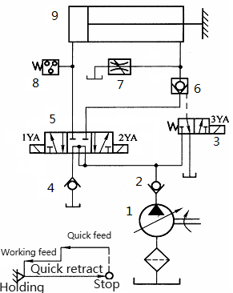

（1）
Solenoid Working States
Solenoid Working States | 1YA | 2YA | 3YA
Rapid feed | ＋ | － | ＋
Working feed | ＋ | － | －
Hold | ＋ | － | －
Quick retract | － | ＋ | －
Stop | － | － | －

（2）In fast forward, the oil inlet circuit is: hydraulic pump 1→ check valve 2→ three-position five-way electromagnetic directional valve 5 (left) → hydraulic cylinder 9 left chamber. The oil return circuit is: hydraulic cylinder 9 right chamber → hydraulic control check valve 6→ three-position five-way electromagnetic directional valve 5 (left) → hydraulic cylinder 9 left chamber.

The basic circuit used is the differential connection circuit.

（3）The oil inlet circuit is: hydraulic pump 1→ check valve 2→ three-position five-way electromagnetic directional valve 5 (left) → hydraulic cylinder 9 left chamber. The oil return circuit is: hydraulic cylinder 9 right chamber → speed control valve 7→ oil tank.

The basic circuit used is the return oil throttling speed regulating circuit.

第 4 页(共 4 页)

